**Home task**

**Task 1. Choose the correct words to complete the conversation. One word is extra.**

**what’s well happens similar basically feature let happen**

**A:** Here's our new website - __let_______________ me explain how it works.

**B:** OK. Actually, Joe, it looks _similar________________ to the old system.

**A:** Yes it does, but __ basically ____________ different is the ordering system.

**B:** So _what’s ____ ____ happen ________ , the user enters more information.

**A:** That's right. What ___ happens ____________ is that you're asked for more personal data.

**B:** OK. I understand.

**A:** One other ______ feature __________ is that it asks you if it's your first visit to the site.

**B:** Does it ask for your email address too?

**A:** Yes. And as _____ well ___________ as your email, it also asks for your password.

**Task 2. Choose the correct options to complete the sentences.**

1. You can see what happens when

* is started the system.
* do you start the system.
* you start the system.
* starts the system.

1. It may seem very complicated at first,

* but the fact it's very difficult.
* but factually it's very difficult.
* but in real it's very easy.
* but in fact it's very easy.

1. One benefit is that it's a lot more accurate, but one

* drawback is that it's slow.
* whereas is that it's slow.
* bad news is that it's slow.
* difficult is that it's slow.

1. OK, you've told us the good news, but what's the

* up side?
* downside?
* side?
* other hand?

1. The better the car, the high the price.

* the price higher.
* the highest the price.
* the higher the price.
* the high the price.

**Task 3. Choose any app / database / website … . Make a 2-3-minute presentation about how it works. Use the vocabulary from the lesson to do so.**

**The key.**

**Task 1.**

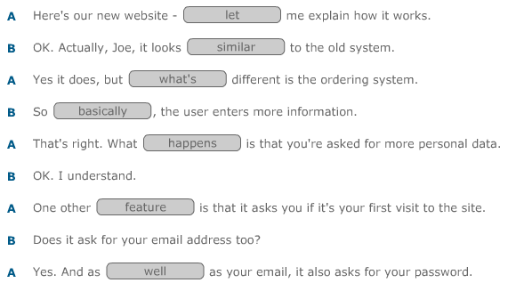

**Task 2.**

